**Creation of VPC Peering**

In order to perform the VPC peering in AWS cloud the pre-requisites are:

* Two VPC with different IP address range.
* Two EC2 instances in each VPC.

**Note:** We can configure VPC peering between two VPCs even if there are no EC2 instances in them. To verify that the VPCs are successfully peered, we usually launch instances in each VPC and test the connection between them.

Block Diagram:

VPC-Peering

Instance-02

Instance-01

Subnet-02

VPC-02: 172.16.0.0/16

**VPC-01**:10.10.1.0/16

Subnet-01

Fig: Block Diagram of VPC peering.

Let’s perform it in practically:

**Step1:** Create Two VPC’s (VPC-01 & VPC-02).

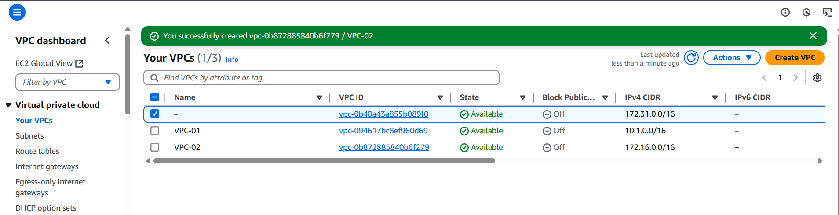

Fig: VPC-01 & VPC-02 are created successfully.

**VPC’s ID:**

**VPC-01:** vpc-094617bc8ef960d69

**VPC-02:** vpc-0b872885840b6f279

**Step2:** With in the VPC-01 configure subnet, internet gateway and Route Table.

Case1: Creation of Subnet-01 with the VPC-01.

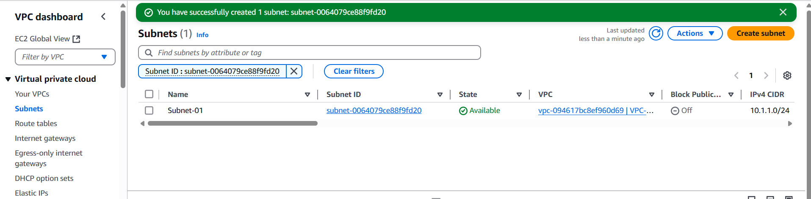

Fig: Subnet (subnet-01) is created.

Case2: Create the Internet gateway (VPC01-IGW) and attach it to VPC-01.

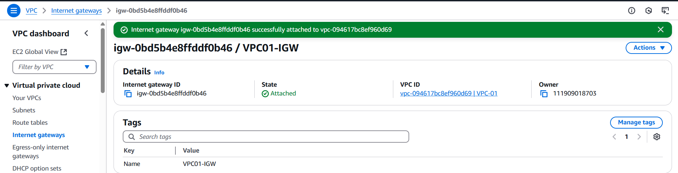Fig: Internet gateway (VPC01-IGW).

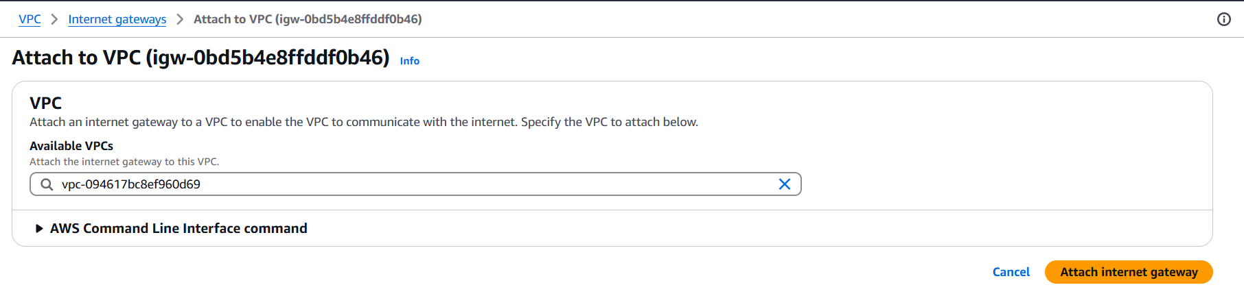Fig: Attaching of VPC01-IGW to the VPC-01.

Case3: Create Route Table (VPC01-RT).

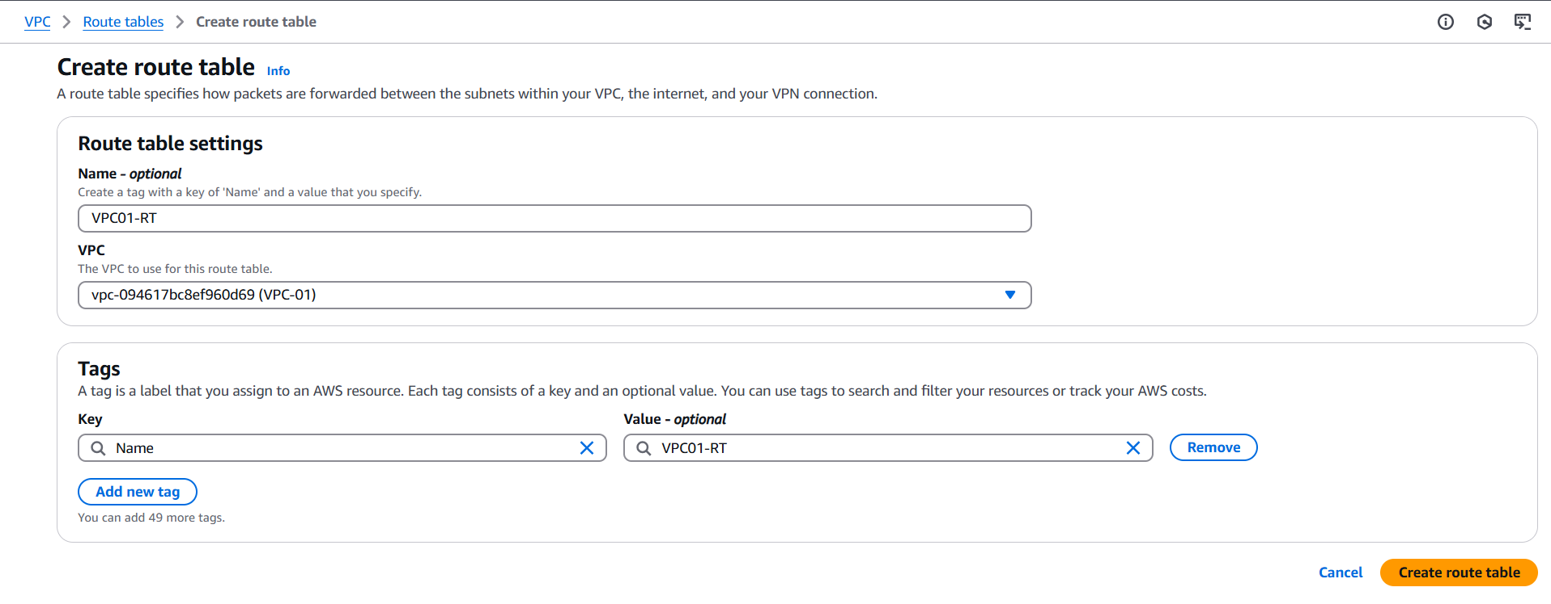

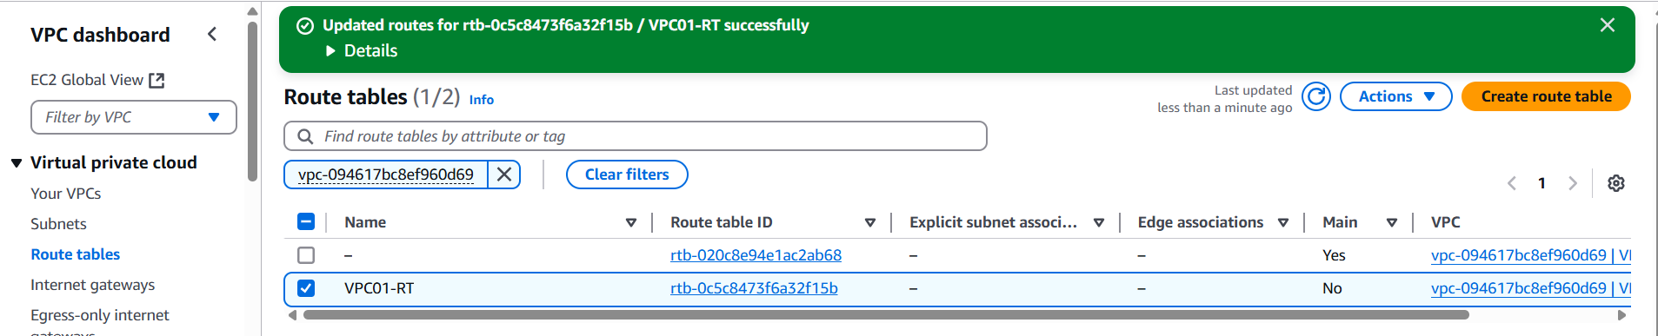

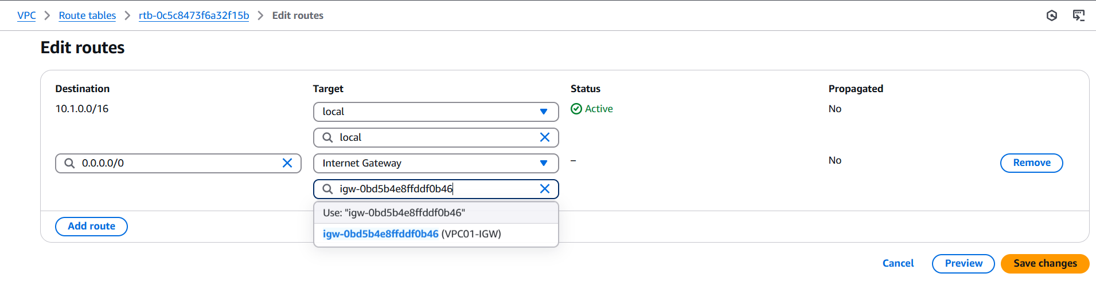Fig: Edit Route of route table VPC01-RT.

**Step3:** Create and configure the Security group for the VPC-01.

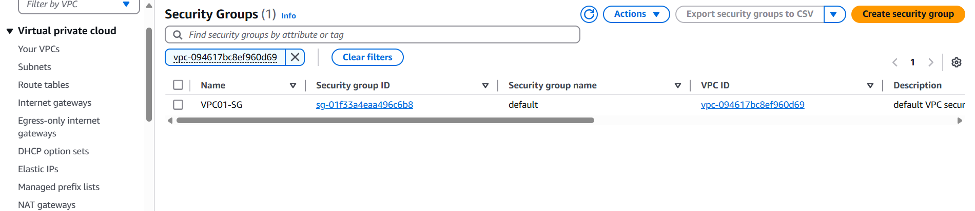

Fig: Security group (VPC01-SG).

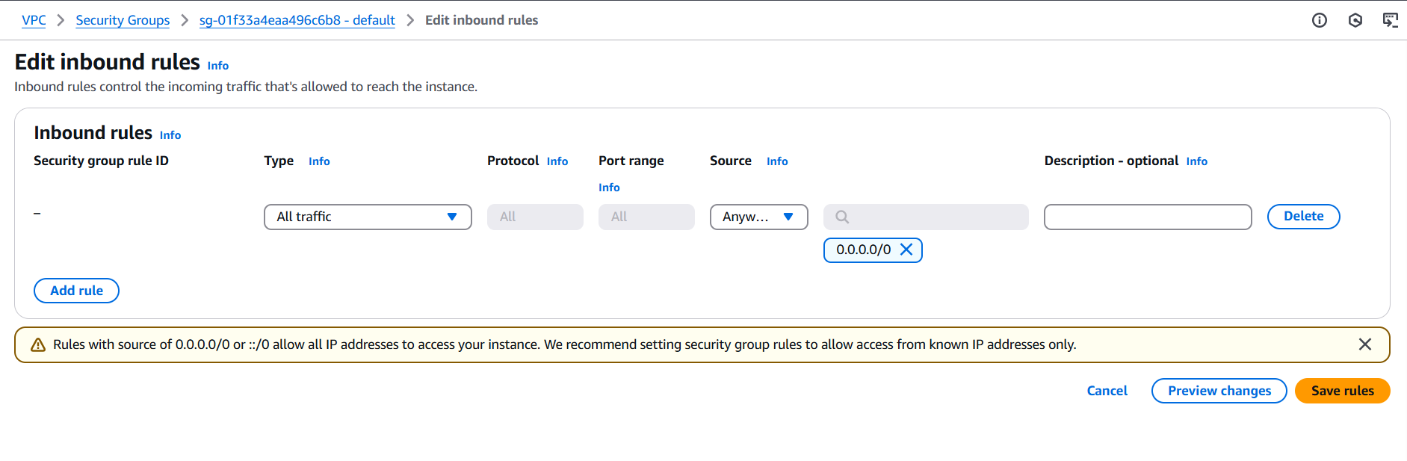

Fig: Configuring of inbound rules of VPC01-SG.

**Step4:** Create an EC2 instance (Instance-01) in VPC-01.

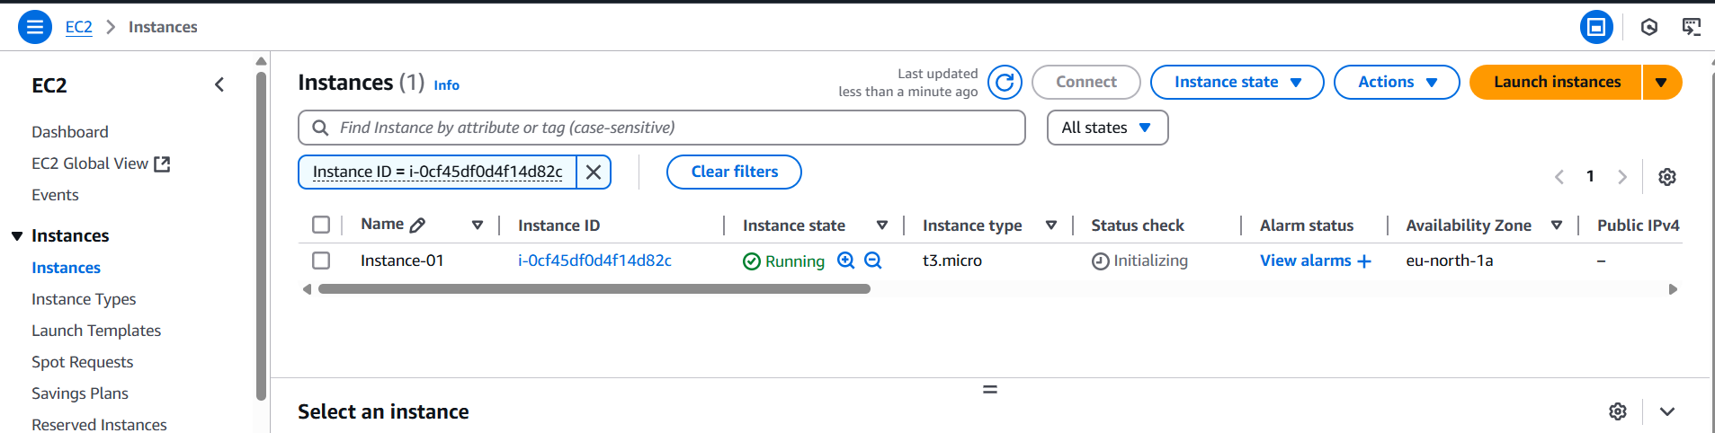

Fig: EC2 instance (Instances-01).

**Step5:** Now similarly within the VPC-02 perform above tasks:

* Create the Subnet (Subnet-02),
* Create internet gateway (VPC02-IGW) and attach to it to the VPC-02
* Create the Rout Table (VPC02-RT),
* Create the Security Group (VPC02-SG).
* Create the EC2 instance (Instance-02) within the VPC-02 of subnet-02

Case1: Creation of Subnet within the VPC-02.

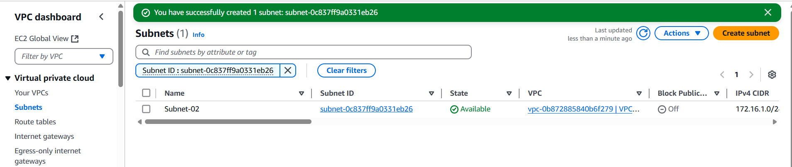

Case2: Create internet gateway (VPC02-IGW) and attach to VPC-02.

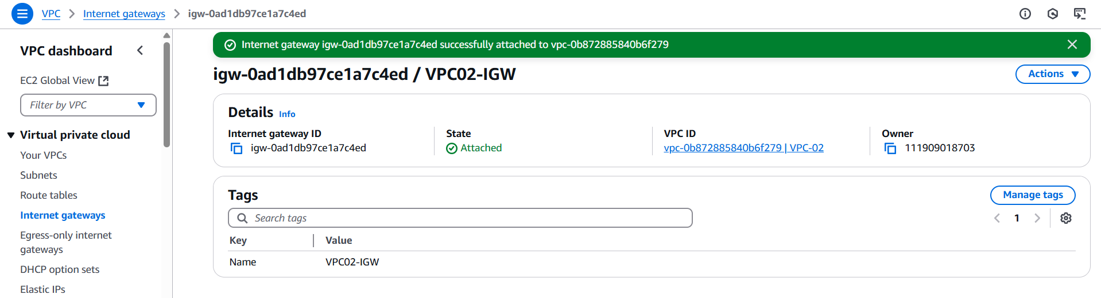

Fig: Internet gateway (VPC02-IGW)

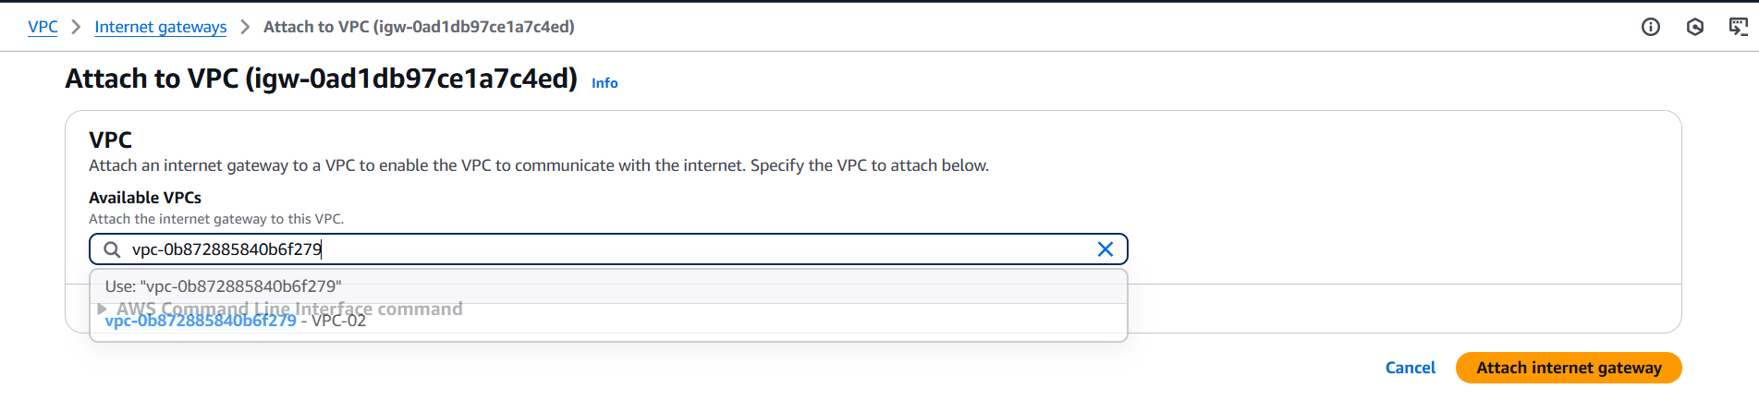

Fig: Attaching to the VPC-02.

Case3: Create a Rout Table (VPC02-RT).

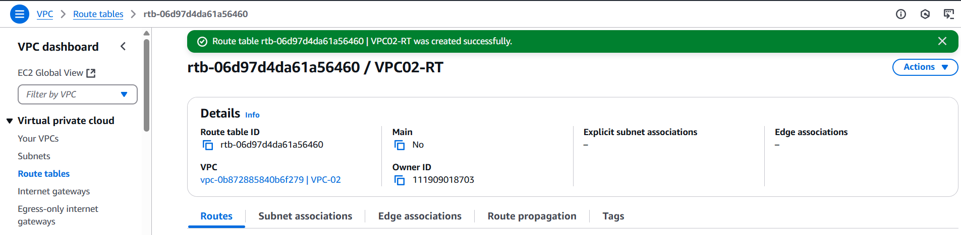

Fig: Route Table (VPC02-RT).

Case4: Create the Security Group (VPC02-SG).

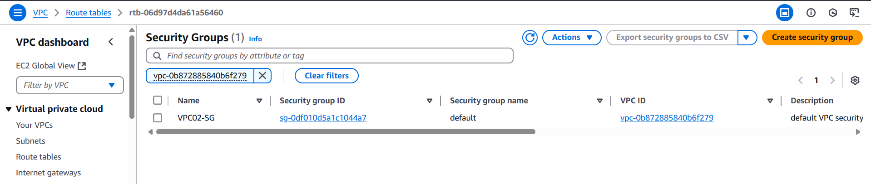

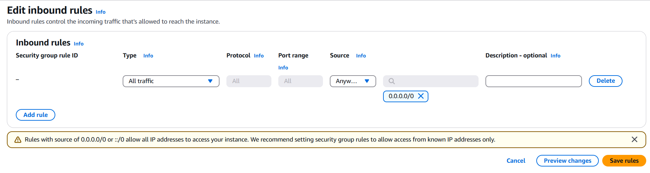

Fig: Configuring VPC02-SG inbound rules.

Case5: Create the EC2 instance in VPC-02.

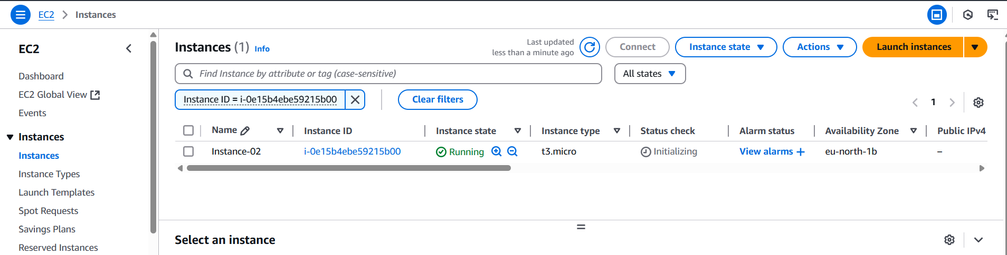

Fig: EC2 instance (instance-02).

**Note:** While creating the EC2 instance we can choose same Key pair for both the instances (Instance-01 & Instance-02) in order to login into the intances.

**Step6:** Now configure the VPC peering.

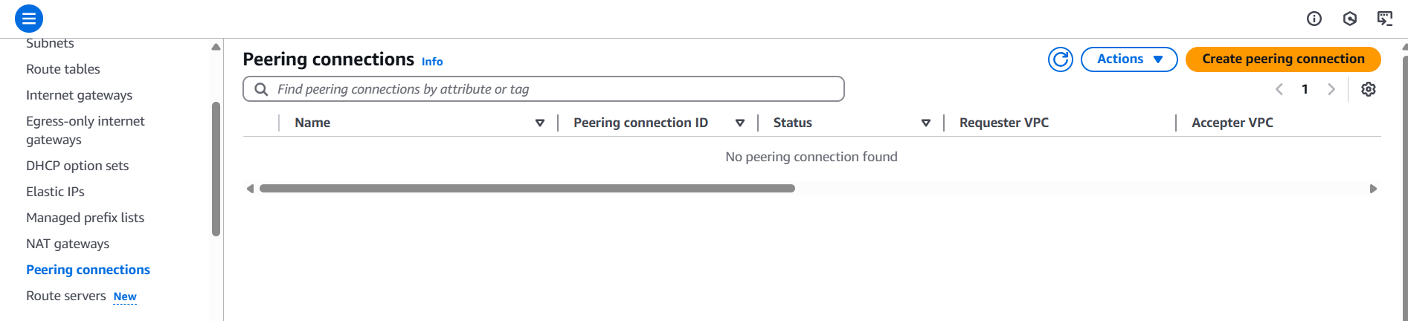

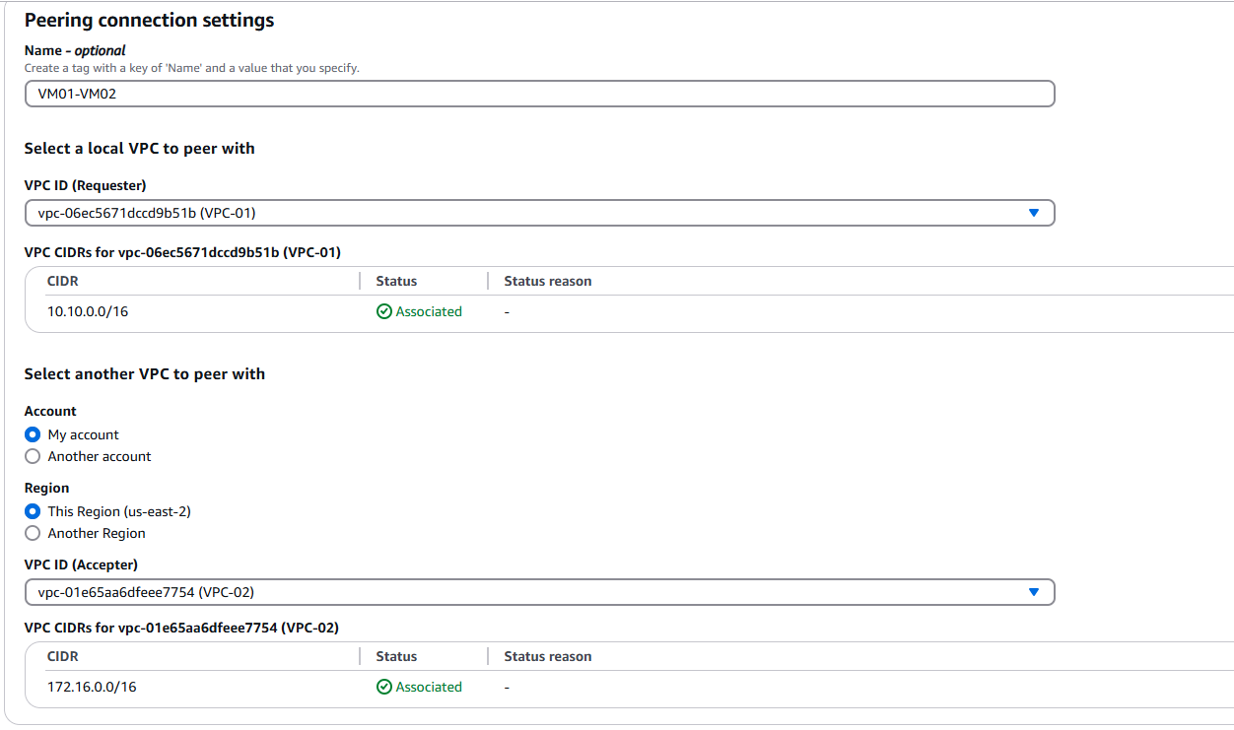

Fig: Configuring of VPC Peering.

**Note:** After creating the peering connection, the two Instances (Instance-01 & Instance-02) until unless we accept peering connection and configuring Rout Tables in both VPC for peering connection.

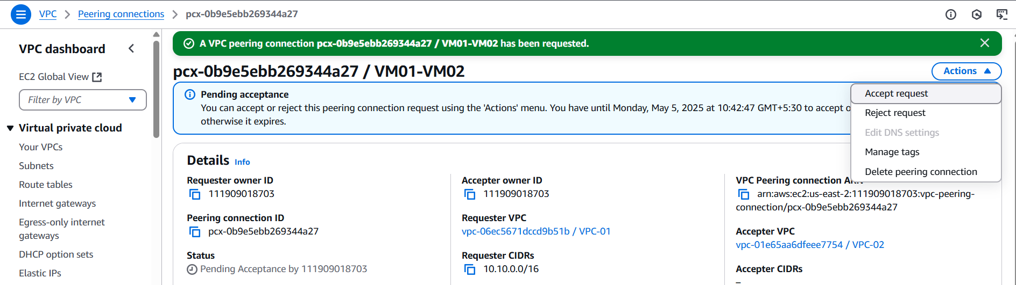

Fig: Accepting of Peering connection request.

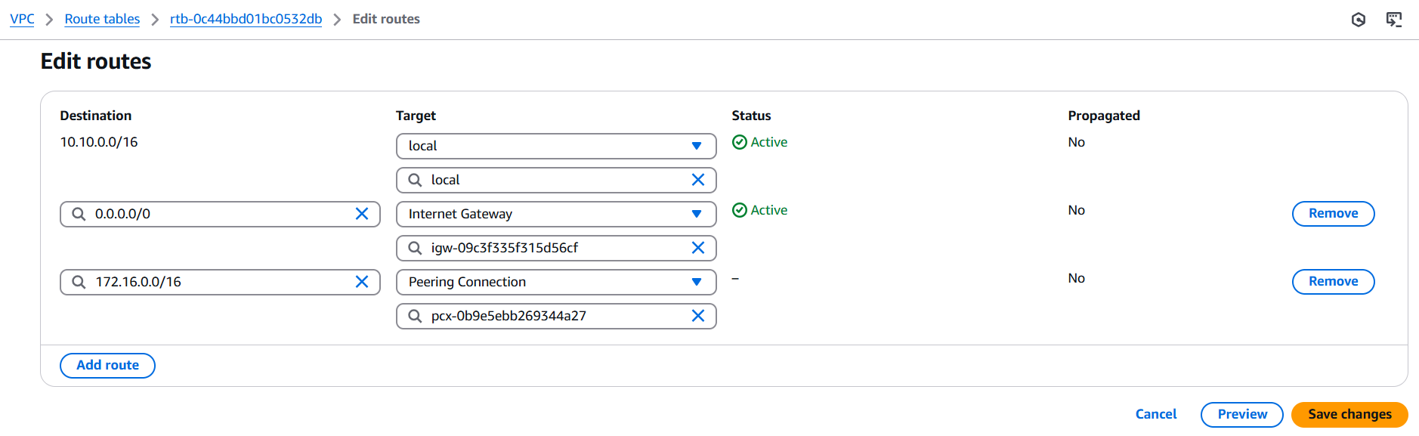Fig: Configuring the Rout Table (VPC01-RT) for peering connection.

The above rout rule say’s that whatever the traffic is coming from CIDR Range (172.16.0.0/16) should use peering connection only.

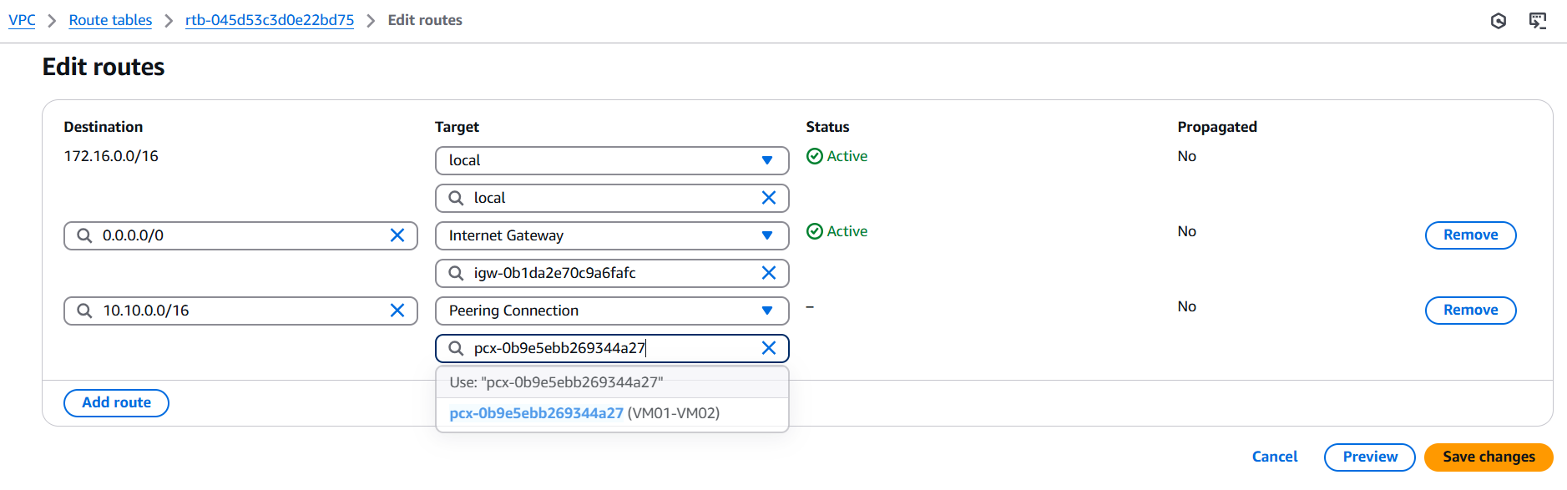

Fig: Configuring Rout Table (VPC02-RT) for VPC peering connections.

The above rout rule say’s that whatever the traffic is coming from CIDR Range (10.10.0.0/16) should use peering connection only.

**Step7:** Now Login into the Instance-01 and ping the Private IP of Instance-02.

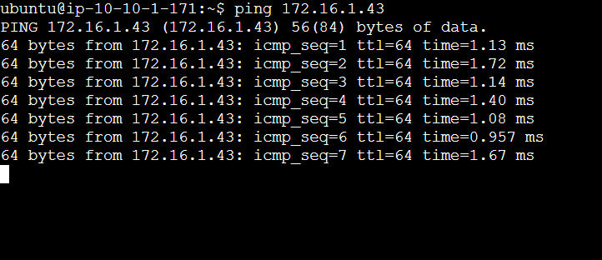

**Step8:** Similarly Login into the instance-02 and ping the private IP of Instance-01.

